Enterprise Network Design

Author: George Aslanidis

Scenario
Your company, currently located at the Eastern part of Thessaloniki plans to build a new building to support non-technical divisions at the center of the city. As a network administrator, you have been asked to design and implement a network to support operations for the following departments:
- - Sales: 50 PCs, 2 Printers, 0 laptops
- - Product Management: 55 PCs, 3 Printers, 0 laptops
- - Finance: 23 PCs, 2 printers, 0 laptops
- - HR: 0 PCs, 1 printer
- - Remote Network: 1 Server, 1 PC
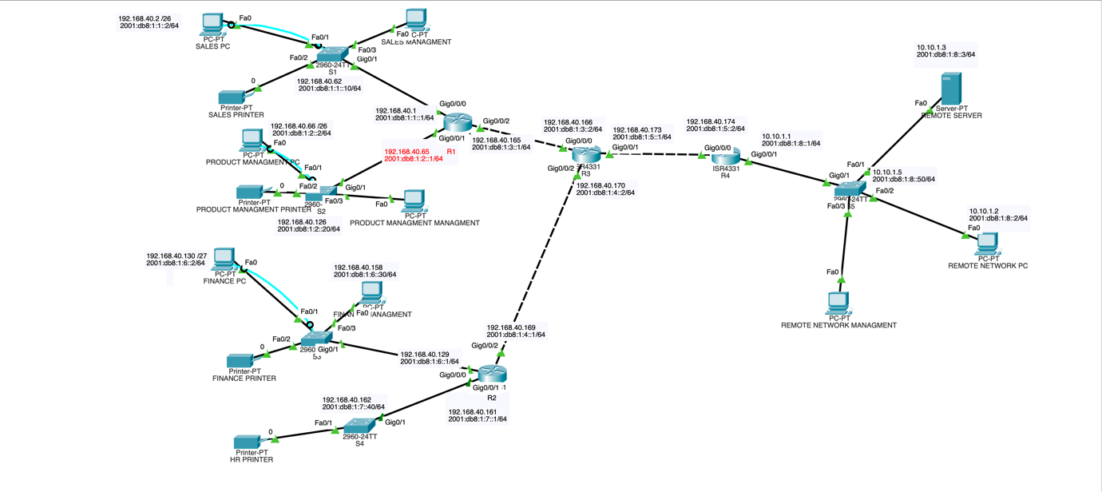

Hardware
Routers: I used four 4331 routers:
  - R1 for the Sales and the Product Management Network
  - R2 for the Finance and the HR Network
  - R3 as intermediary between R1 – R2 – R3
  - R4 for the Remote Network

Switches: I used five 2960 switches:
  - S1 for the Sales Network
  - S2 for the Product Management Network
  - S3 for the Finance Network
  - S4 for the HR Network

IP Addressing
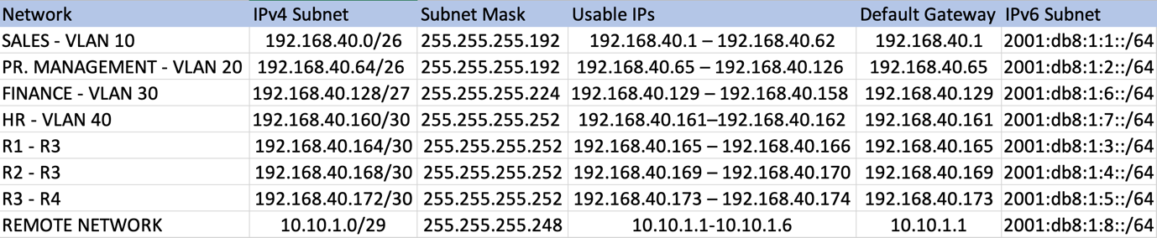
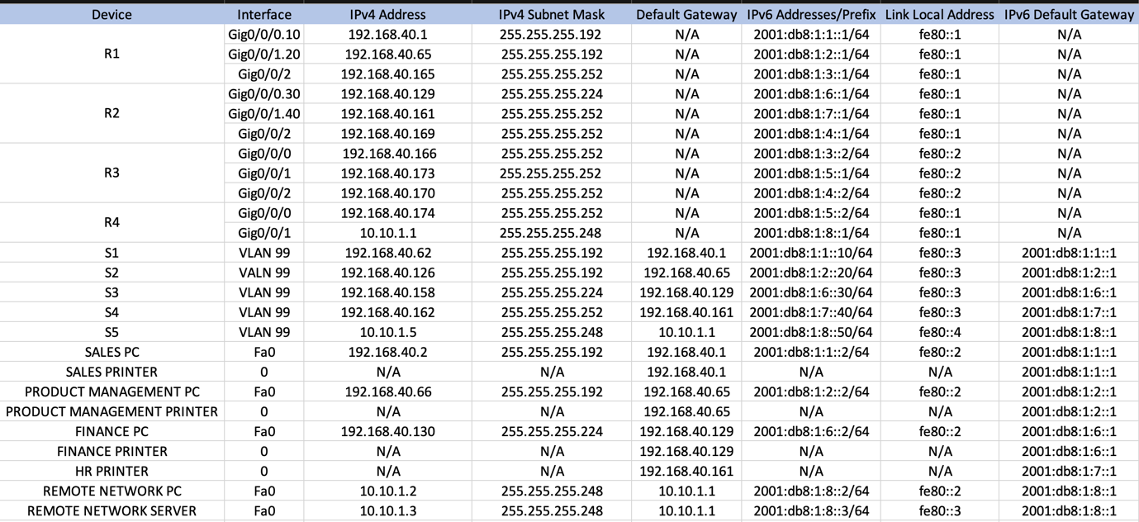

IPv4, IPv6 Assignments:
End devices
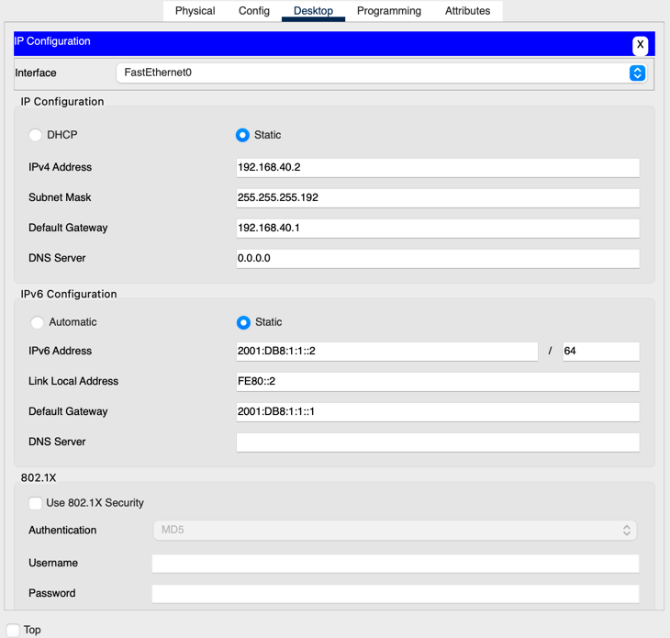
Routers IPv4, IPv6
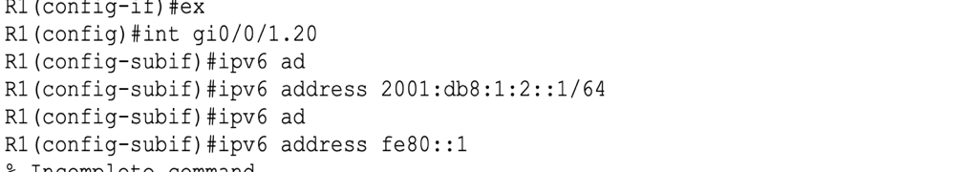
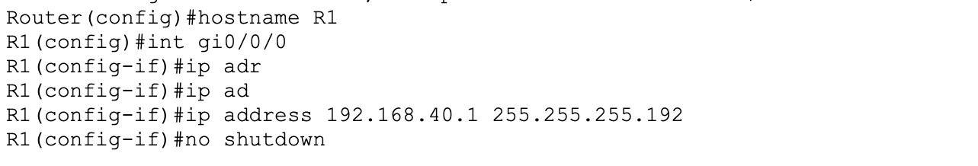
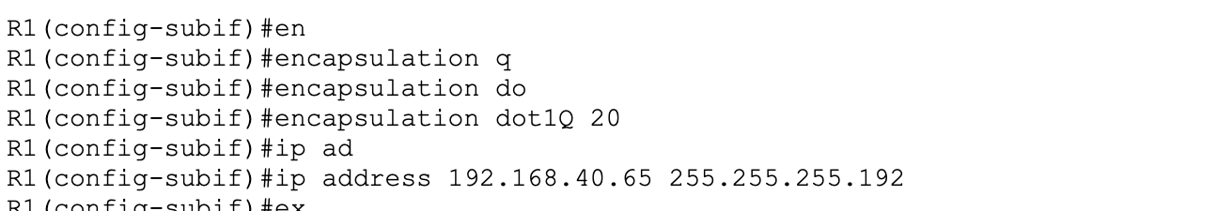

Security
Login Password (line con 0):
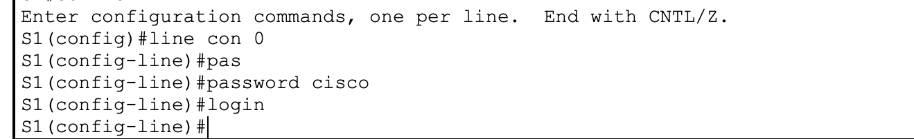
Privileged EXEC Mode Secret Password & Service Password Encryption
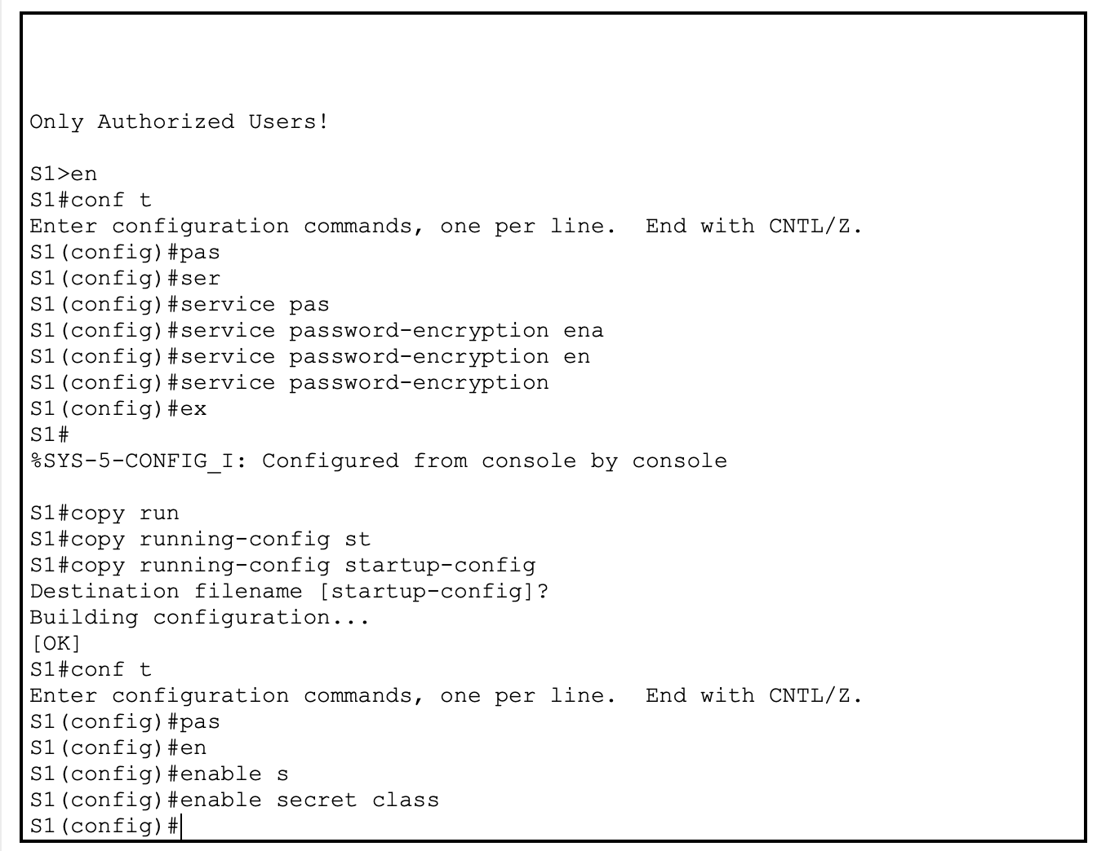
Message of the Day Banner

SSH for Routers
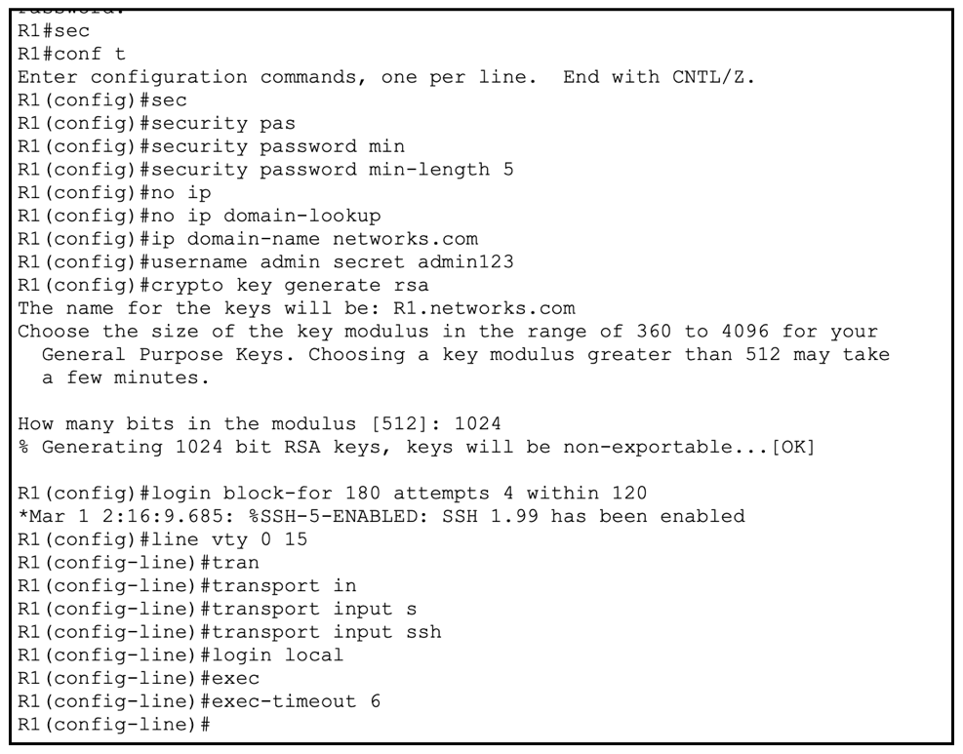
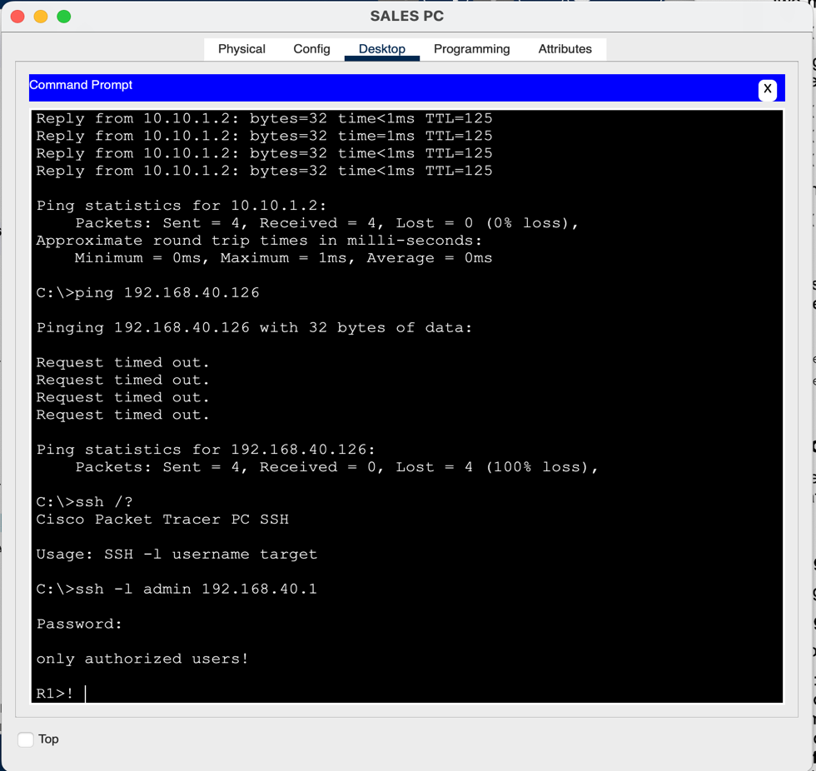

SSH for Switches
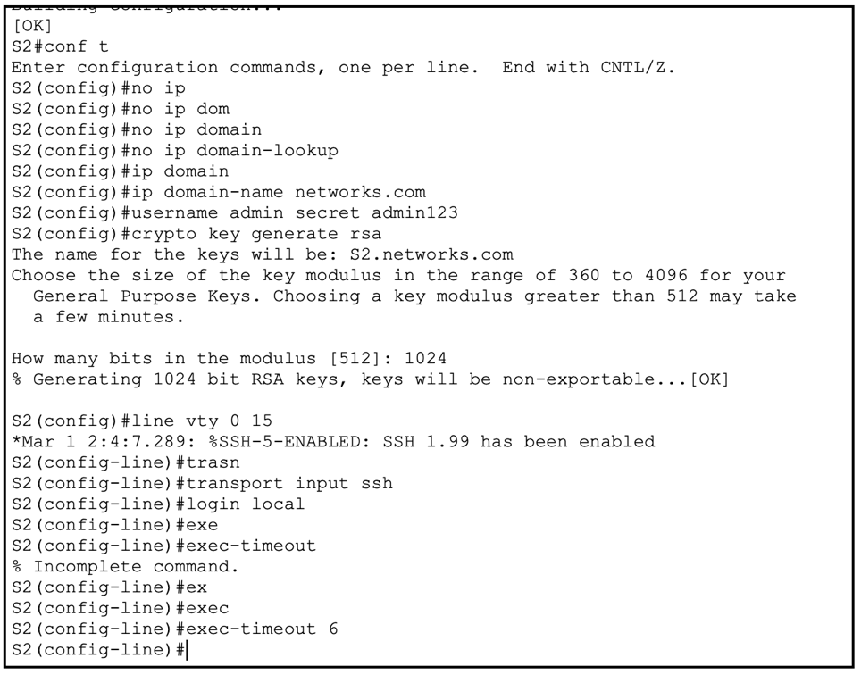
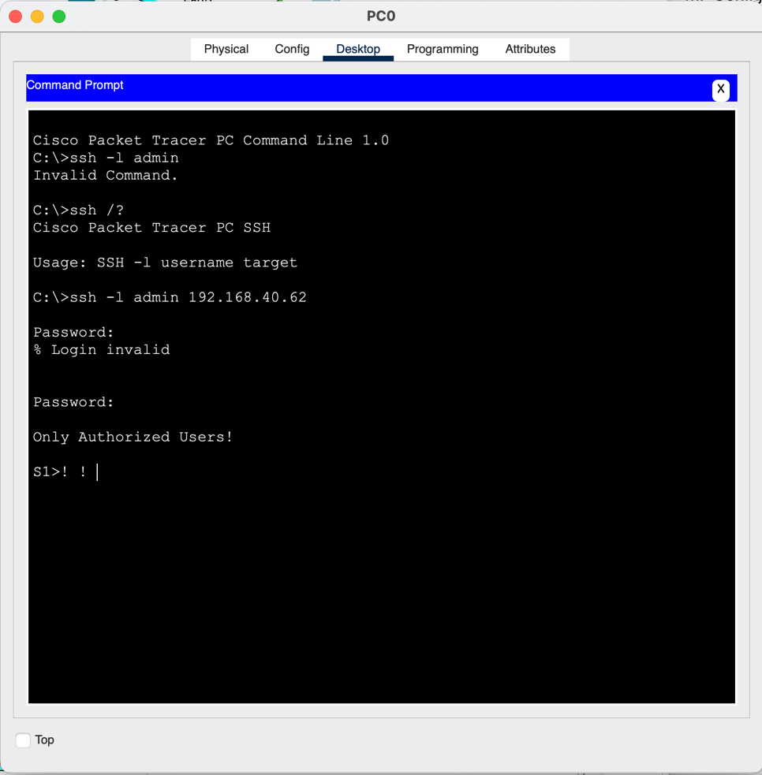
        - All Routers can be accessed through SSH.
        - Switches can be access via SSH if there is a “Management” pc in the network which I added solely for this reason, and it is not configured to communicate effectively within the network

VLANs
VLAN CREATION
- All VLANS where created in every switch in the project
- Switches’ Ports were assigned properly to their respected VLAN
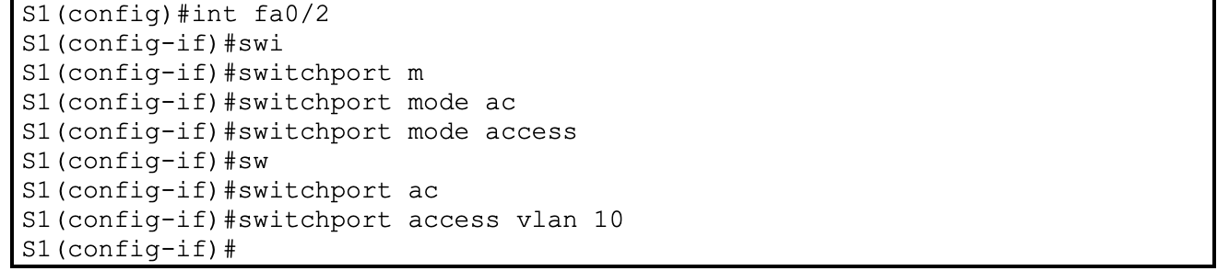
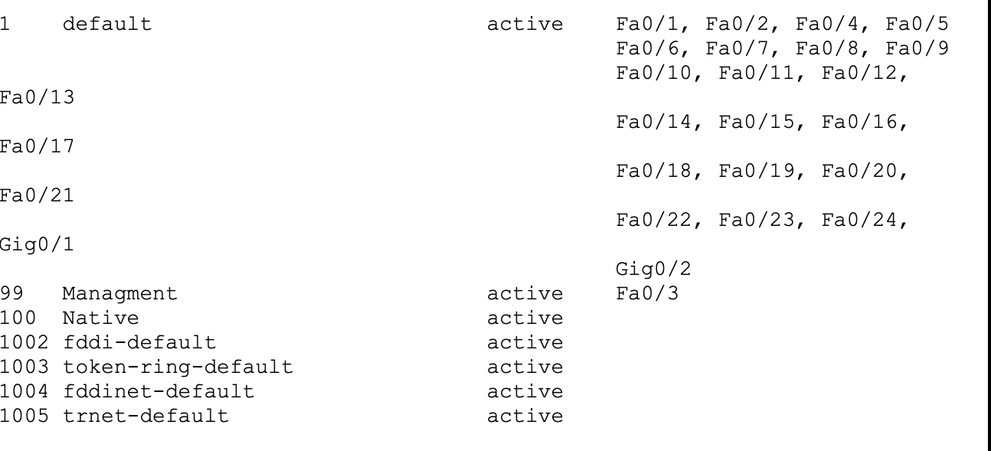

Management Interface VLAN 99 Creation and IP Assignment
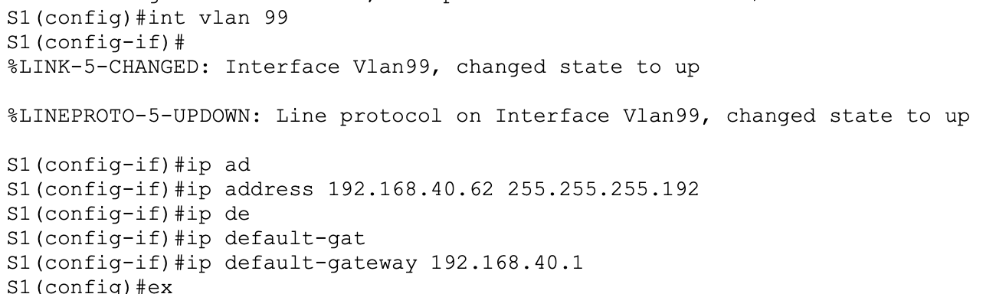

Native VLAN Assignment
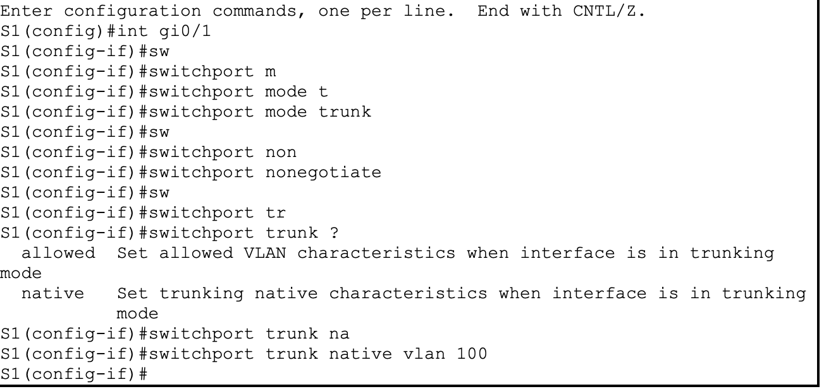

Trunk Configuration
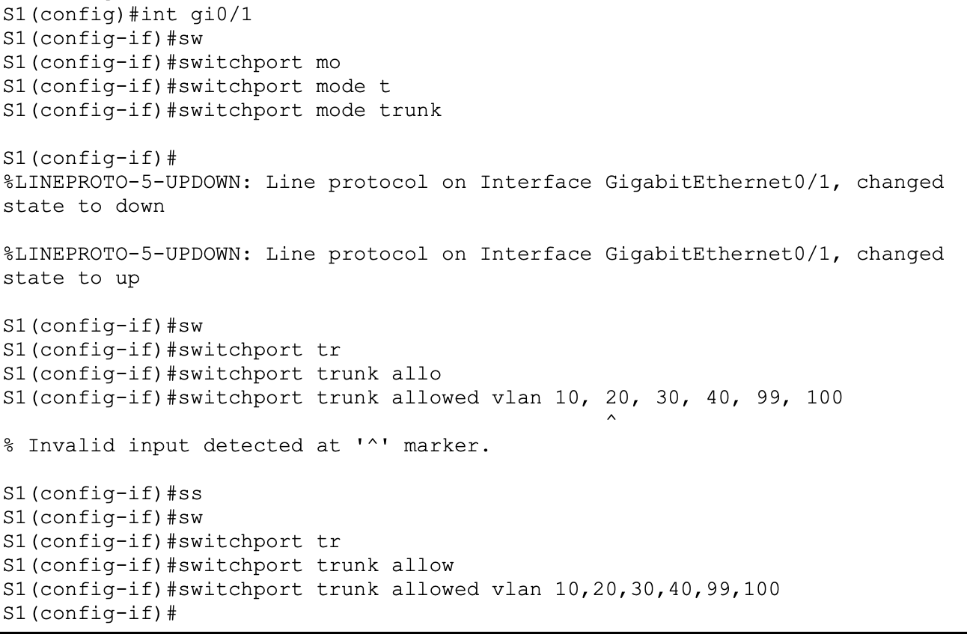

Routing
IPv4 Routing
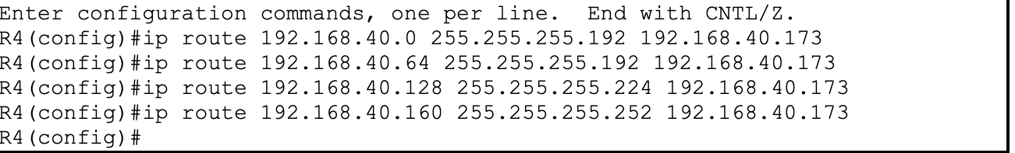
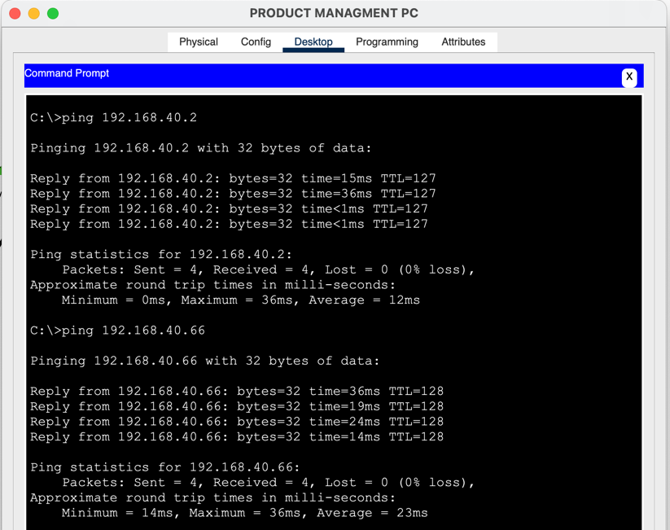

Routing
IPv6 Routing
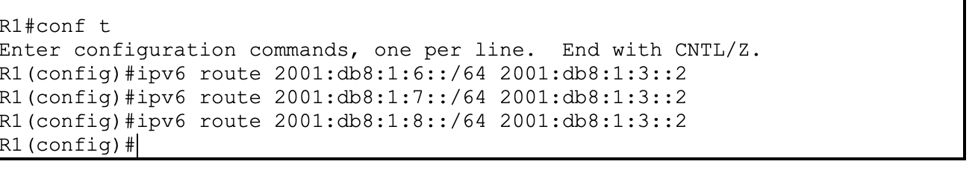
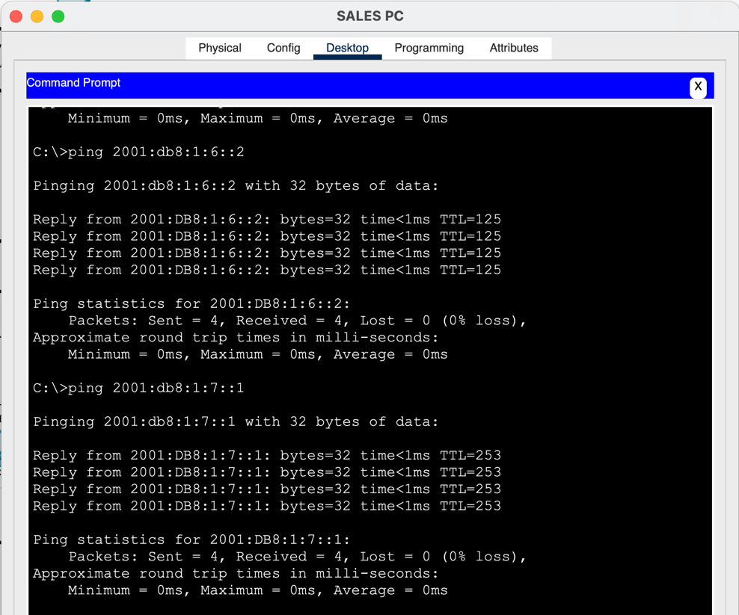

PASSWORDS
  - Login: cisco (line con 0)
  - EXEC Mode: class (enable)
  - SSH:
    - Username: admin
    - Password: admin123

